Royal Engineering Company

ENGINEER’S CONTRACTOR’S GENERAL ORDER SUPPLIERS

RECO

***Specialist in: All Kinds of Fabrication, Erection & Welding***

***Ref: Date: <To2>***

**TO WHOM IT MAY CONCERN**



This is to certified that Mr. <Name> S/o <fname> worked in our Company as a “<Designation>” from <From2> to <To2>.

During this period he is very honest and hardworking men. He is a punctual and obedient worker and his behavior with staff was very good.

We wish him a bright future.

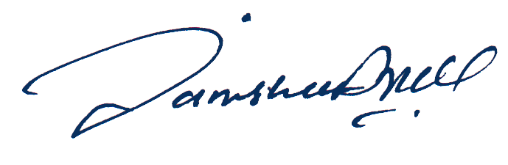

**DIRECTOR**

**ROYAL ENGINEERING COMPANY**

**237/A, New P.A.F. Officers Colony Survey No. 15 Zarar Shaheed Road, Lahore Cantt.**

**N.T.N. 1441009-5**

**Office: 042-6106570-042-6655080**

**Fax: 042-5945467**

**Mobile: 0300-8450509-0300-4252334**

**E-mail: reco_pak@yahoo.com**